**CS2001**

**Screens:**

**Homepage**

* Search bar in middle
* 4 other icons

**Quiz**

* Random selection of quiz each time
* Feedback as below is either
* Same answer screen as below but with timer

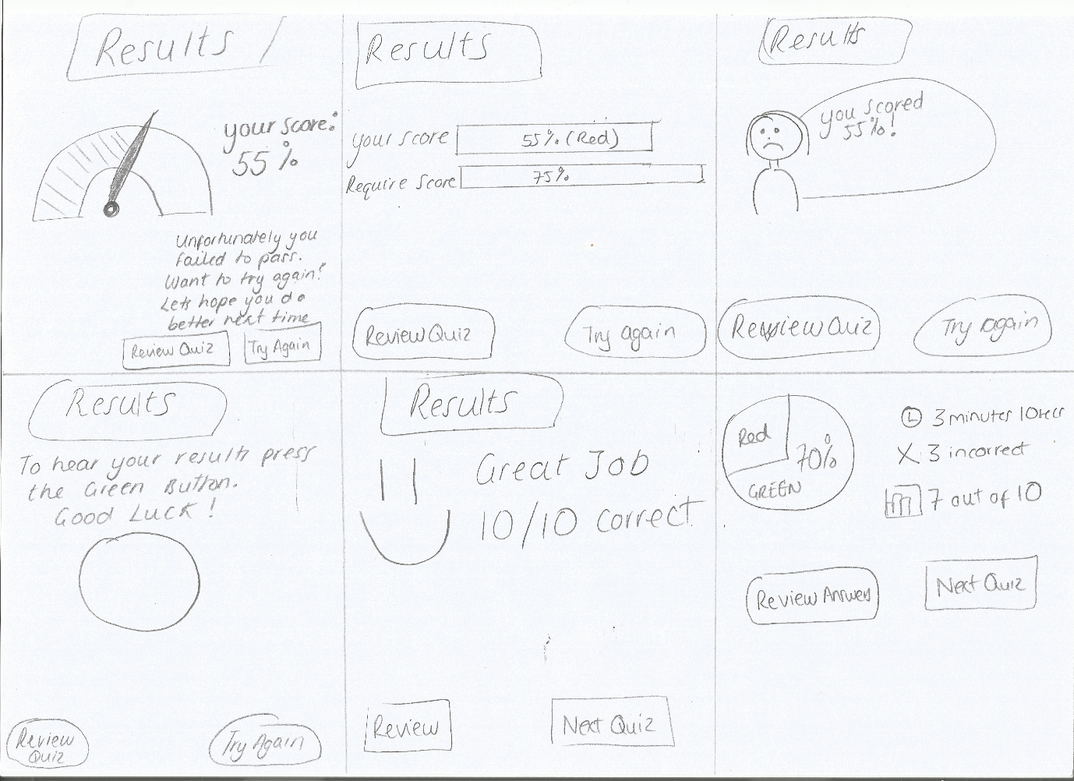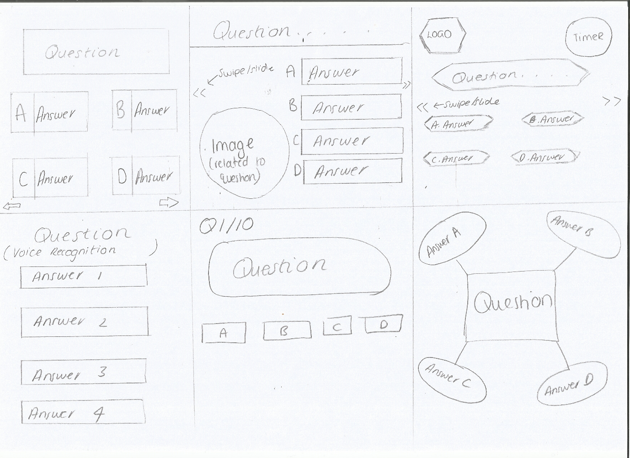

**Videos**

* Thumbnails and title as lists
* Tap on video to expand and watch

**Question selection screen**

* List of related questions depending on search
* Click and expansion or click to be directed to another screen

**Settings**

* Only if have enough content to be practical
* Quiz timer
* Woman or man face

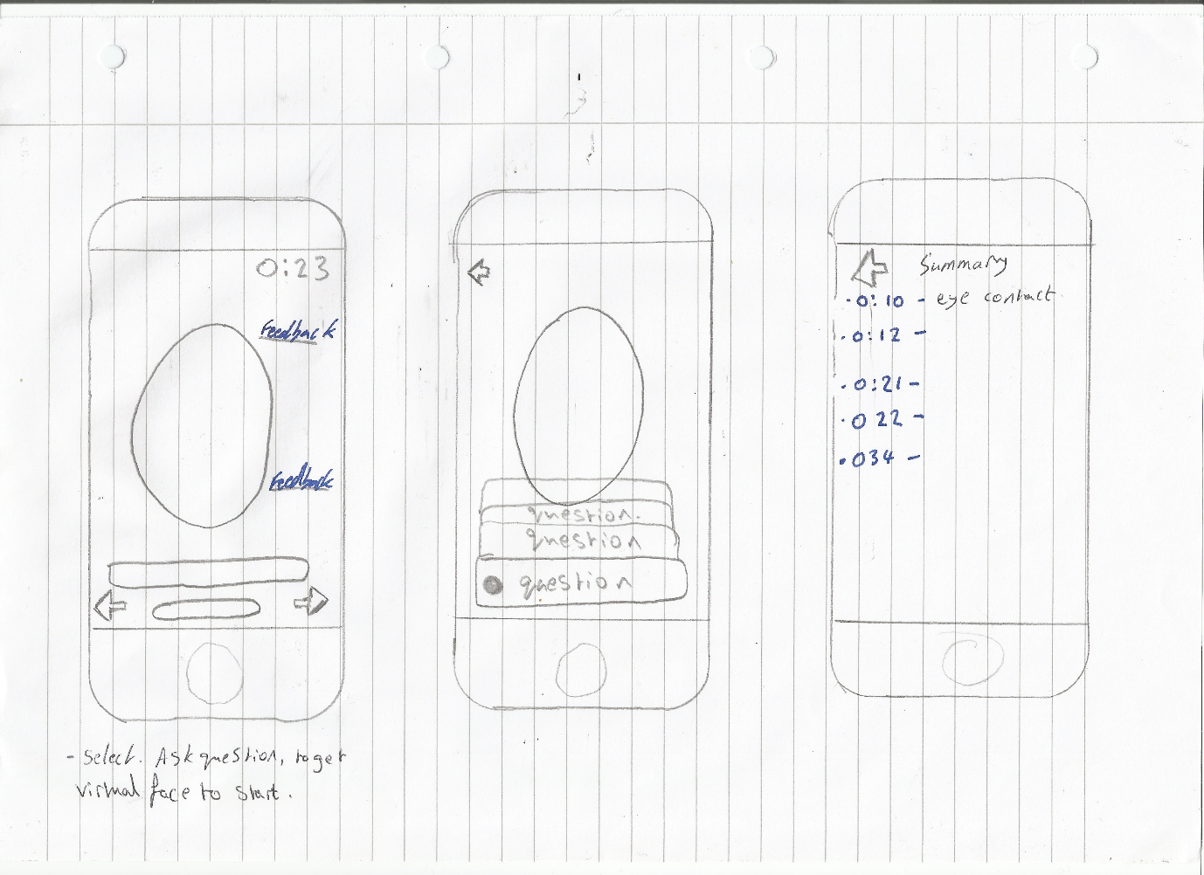**Face to face**

* Feedback when user is talking
* Facial analyser (needs work)
* Summary screen to give feedback

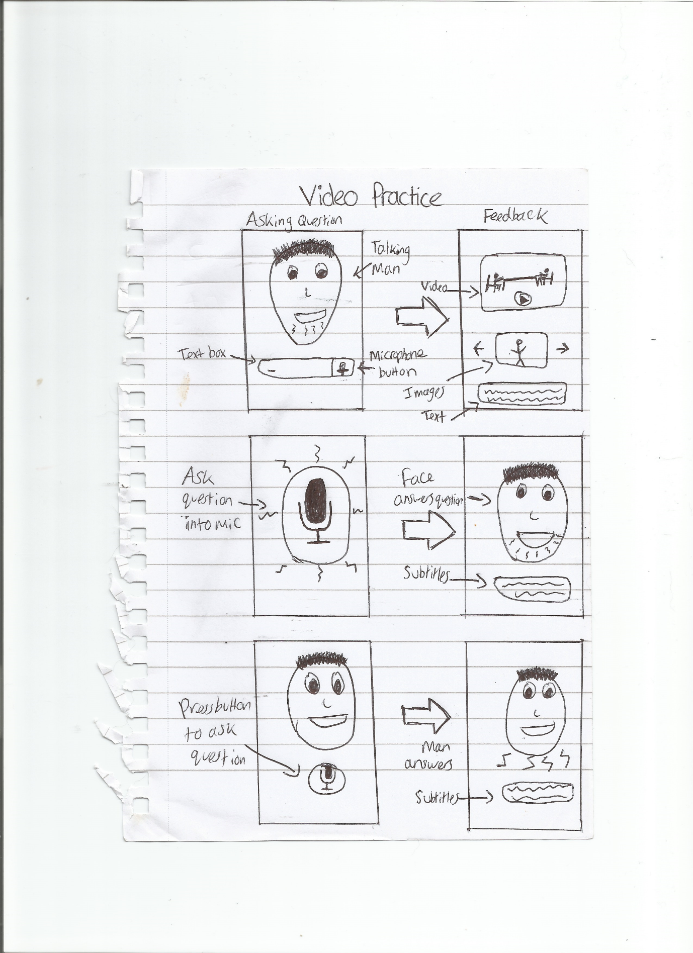

**Data**

* Questions to be asked by interviewer
* Advice on how to answer
* Body language, how to dress
* Questions asked by candidate to interviewer
* Videos and pictures